P Sai Koushik
2200032991
TASK-6 Exercise 1: Mocking and Stubbing
Steps: 1. Create a mock object for the external API. 2. Stub the methods to return predefined values. 3. Write a test case that uses the mock object.
Myservicetest.java
package com.example;

import org.junit.jupiter.api.Test;
import static org.junit.jupiter.api.Assertions.assertEquals;
import static org.mockito.Mockito.*;

class MyServiceTest {

@Test
void testExternalApi() {
// 1. Create mock
ExternalApi mockApi = mock(ExternalApi.class);

// 2. Stub behaviour
when(mockApi.getData()).thenReturn("Mock Data");

// 3. Use mock in service
MyService service = new MyService(mockApi);
String result = service.fetchData();

// 4. Assert + optional verify
assertEquals("Mock Data", result);
verify(mockApi).getData(); // proves the call happened
}
}

Externalapi.java
package com.example;

public interface ExternalApi {
String getData();
}

Myservice.java
package com.example;

public class MyService {
private final ExternalApi api;

public MyService(ExternalApi api) {
this.api = api;
}

public String fetchData() {
// could contain more logic, caching, etc.
return api.getData();
}
}

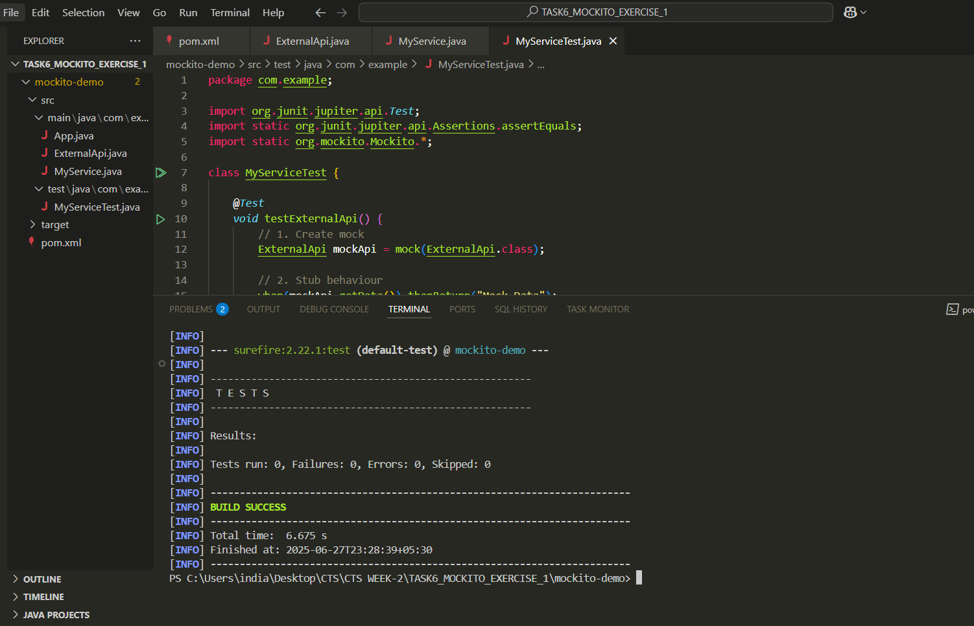
we can see the test run
file format
